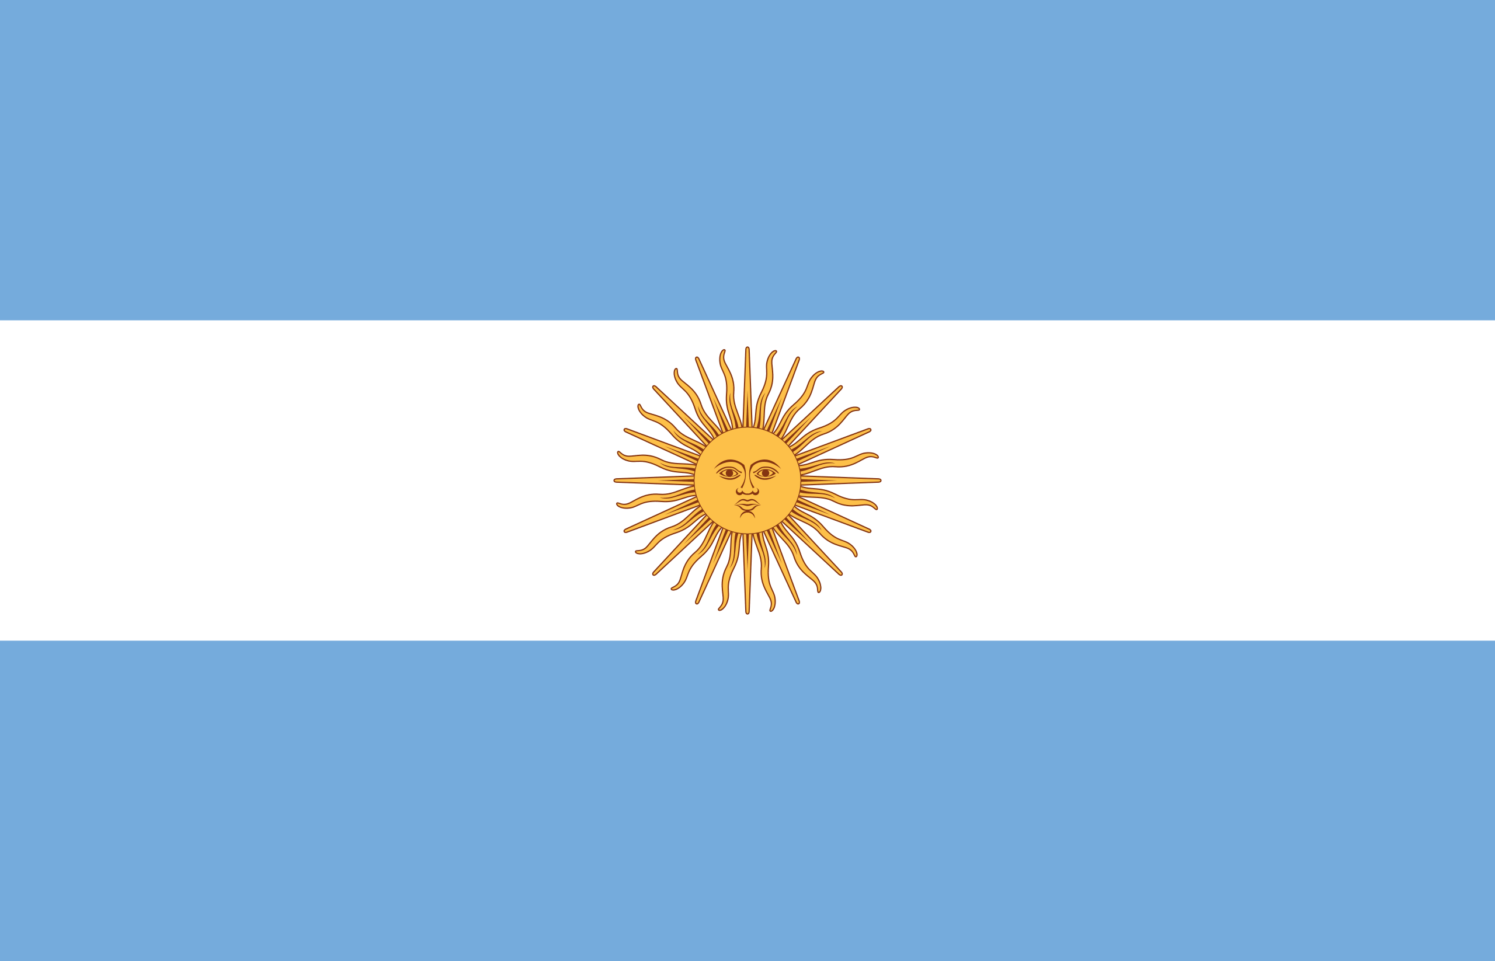ARGENTINA
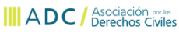
On Friday, October 23rd, the Inter-American Commission of Human Rights debated, for the first time, the complaints of advances and interferences of the National Executive power against the independence of the judicial branch. Lawyers Alvaro Herrero and Torcuato Sozio were present as speakers and representatives of the NGOs Poder Ciudadano and ADC. Ver más
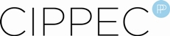
CCIPPEC published the manual "Autoridad de mesa: que tenés que saber" which instructs people who have received a telegram from the electoral authorities designating them as president of a table or poll worker about their role on election day. Ver más
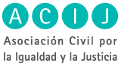
“Budget and Rights” week took place between October 13-16. During the week 6 themes were discussed regarding the public budget and it’s impact on equality, democracy and rights. Ver más
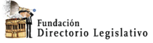
The Court of Appeals from the Federal Judicial Administrative branch, Sala II, decided in favor of the organizations Directorio Legislativo, Asociación Civil por la Igualdad y la Justicia (ACIJ), Asociación por los Derechos Civiles (ADC) and Poder Ciudadano, obligating the Chamber of Deputies to turn in the administrative resolutions previously solicited through a request of public information, and to publish them on the institutional website. Ver más
Poder ciudadano presented “Ojo con el Voto” [Eyes in the Vote], a tool for citizen electoral observation. The tool is a product of an alliance between Poder Ciudadano and Pol-it. “Ojo con el Voto” is an app for smartphones which allows voters to sent a report of their voting experience or inform others and the NGOs about possible irregularities. Ver más
Bolivia
Completion of “Plataforma Virtual”]Virtual Platform= www.yoreportobolivia.org in which the volunteers worked to promote the participation of informed citizens en the elections of October 12th. Ver más

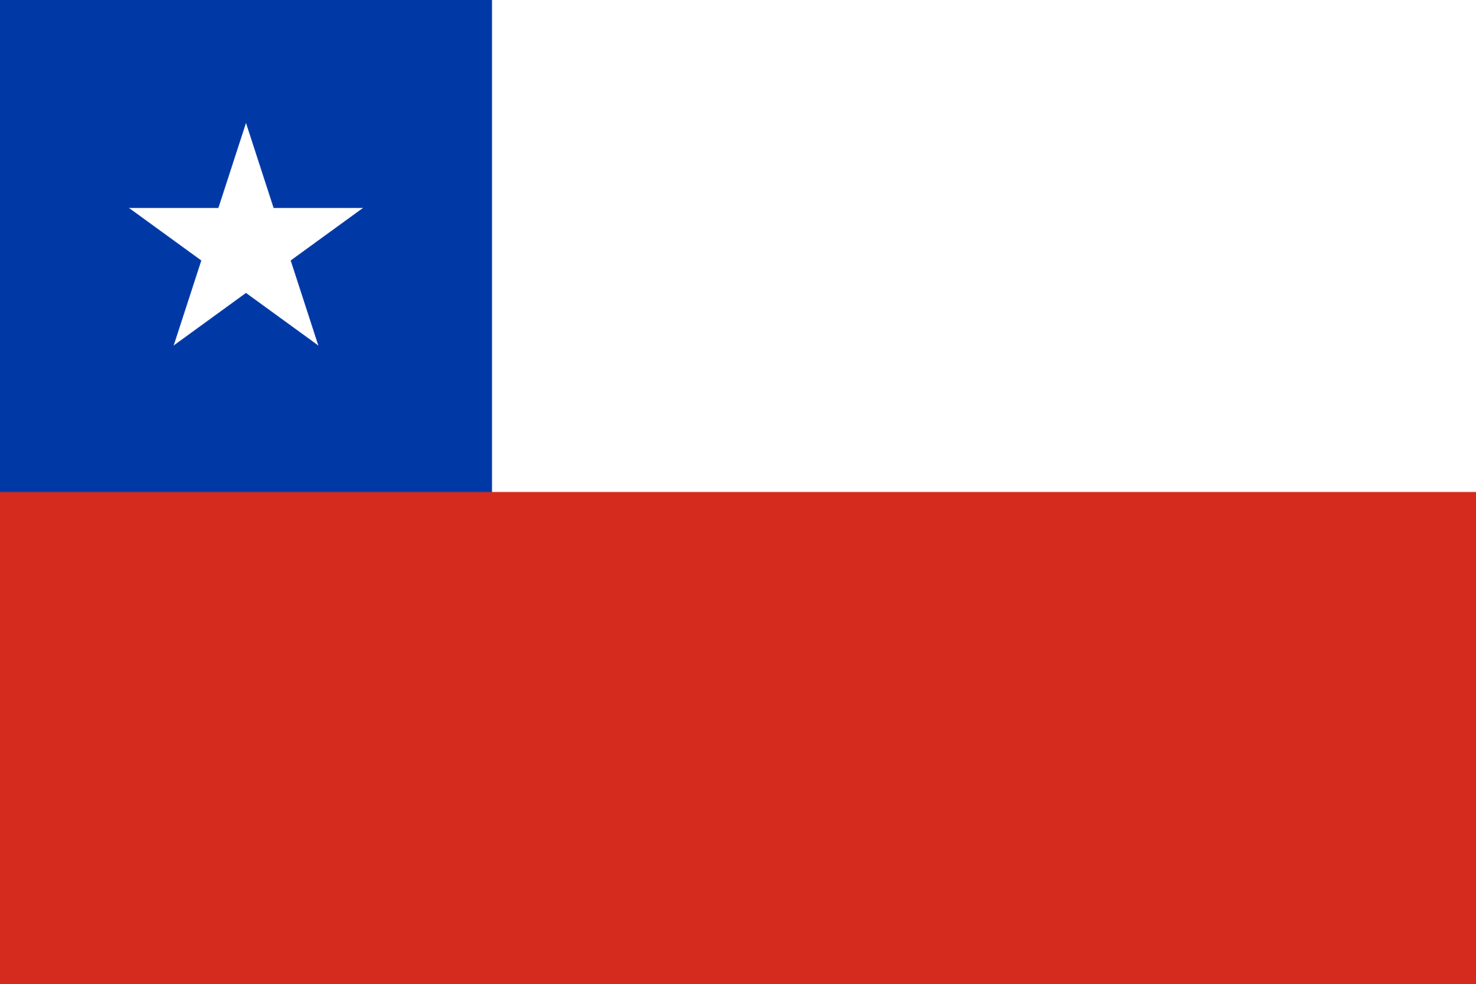Chile
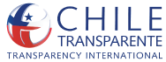
Published a petition to include political parties in law 20,285 and to assure transparency of political parties and the fiscal obligations for the “Consejo para la Transparencia” [Council for Transparency]. Ver más
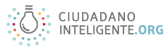
Published a preview of the Congress regarding transparency of the government. Congress approved the bill for the law about Integrity In the Public Sphere. Ver más

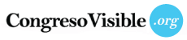
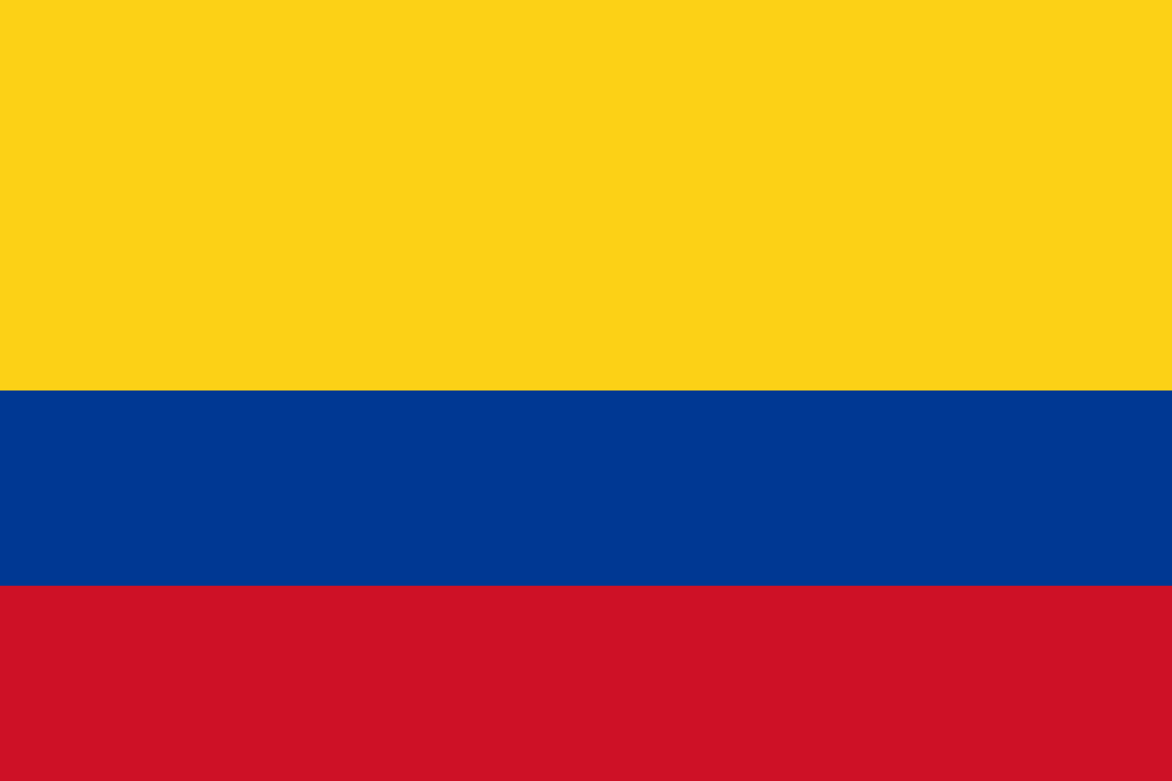Colombia
Relaunched the platform votomovil.com votomovil.co, a tool which began in 2014 that allows citizens of Bogotá, Medllín, Manizales y Cali, to learn with which candidates mayor their values align. Ver más
On September 3rd a forum took place called “Cartagena: Una agenda para el buen gobierno” [Cartagena: An agenda for good government]. The forum consisted of four panels: Cartagena Today, Diagnostics and principal indicators, Challenges that await the next mayor of the city, Lessons of transformation: the cases of Montería and Valledupar, Towards excellent public management: A promise for all, Competitiveness and Wellbeing: The great challenges. Ver más
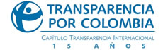
On the September 24-25 in the Center of Excellence of Deloitte, Transparencia por Colombia carried out the sixth Round of Good Practices of Business Transparency, in which they went over the best practices in management ethics, strategies of networking for the strengthening of trust with interest groups, tendencies of good corporate government and active transparency. The event had a total of 147 participants from the business, academic, government, civil society, union, communication and civilian sectors. Ver más
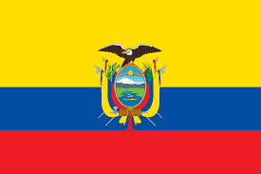Ecuador
In October, the campaign “Asambleísta Transparente” began with the intention of distributing information from legislators and increasing civilian participation. Already 20 legislators have published information about their personal property, accounts, personal background (resumes) and bills they support. Ver más

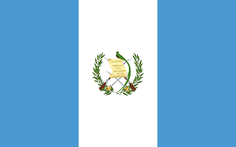Guatemala
Published a report "más inclusión, menos violencia" [more information, less violence] about the observations from Election Day about the search for diverse incidents that affect the development of the electoral process. Ver más
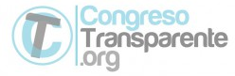
Began an investigation named "Qué nos dejó el congreso" [What Congress left us]. The motivation for the investigation was the lack of productivity in Congress between 2012 and 2015.

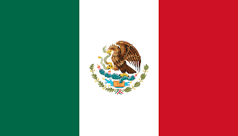México
Fundar, along with other organizations, reported in the Inter-American Commission of Human Rights, a pattern of extrajudicial executions and cover-ups in Mexico. Ver más
The organizations that make up the Latino American Network for Legislative Transparency in Mexico, Impacto Legislativo [Legislative Impact], Fundar, Centro de Análisis e Investigación [Center of Analysis and Investigation], Trasparencia Mexicana y Visión Legislativa [Mexican Transparency and Legislative Vision] began the seminar “Transparencia y Actividad en México: ¿Cómo Evaluar?” [Transparency and Activity in Mexico: How can we evaluate it? Ver más
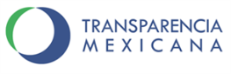
Published the book “Parlamento abierto, logros y retos” [Open Parliament, Successes and Challenges] that describes how to start to open up congresses and parliaments in the world. It contains experiences, interpretations and failures of those to have succeeded in persuading their parliaments to open up and also of those who are still fighting to have their congresses do so. Ver más
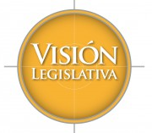
Together with 9 other civil society organizations that promote open parliament, Visión sent a letter to the presidents of the Chamber of Deputies and the Senate with asking that in the debate of the Federal Law of Transparency, the Congress’ would consider the basic characteristics of open parliament and adapt these ideas into the law. Ver más

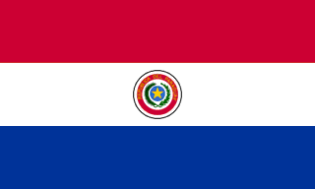Paraguay
Started the first Workshop of Disclosure of Law Number 5,282 “Free Public Access to Public Information and Governmental Transparency,” directed to university students at the Universidad Técnica de Comercialización y Desarrollo (UTCD), regional site Santani. Ver más
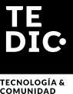
On October 4-5 in Asunción, the first databootcamp took place in Granel. The workshop’s participants included journalists of different medias, programmers and web designers and it was centered on journalism of facts and identification of persons. Ver más
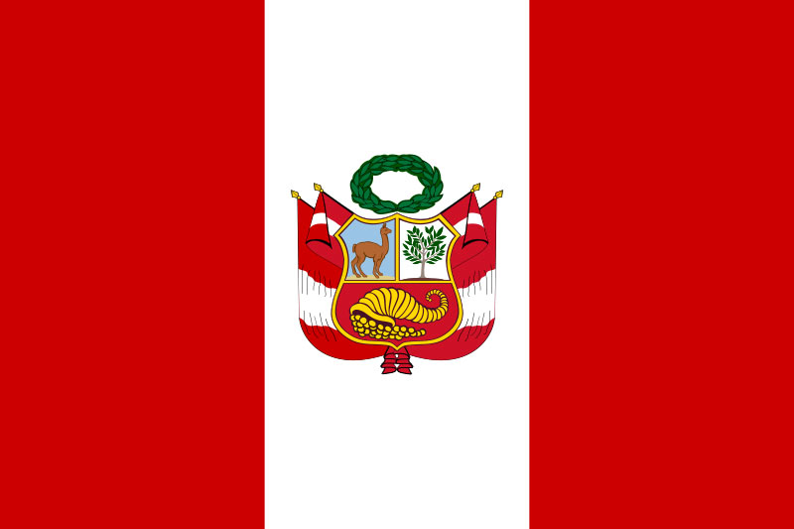Perú
On September 24-25 in Chimbote and Trujillo, respectively, began the cycle of Dialogues for Democracy “2016 Elections: Recuperate Politics.” The events took place with the active participation of representatives of civil society organizations, political leaders, university students and journalists. Ver más
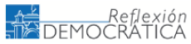
Published “critical points of electoral reform,” stressing the obstacles that currently exist in Congress for such reforms. Ver más

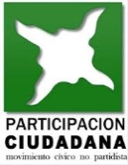
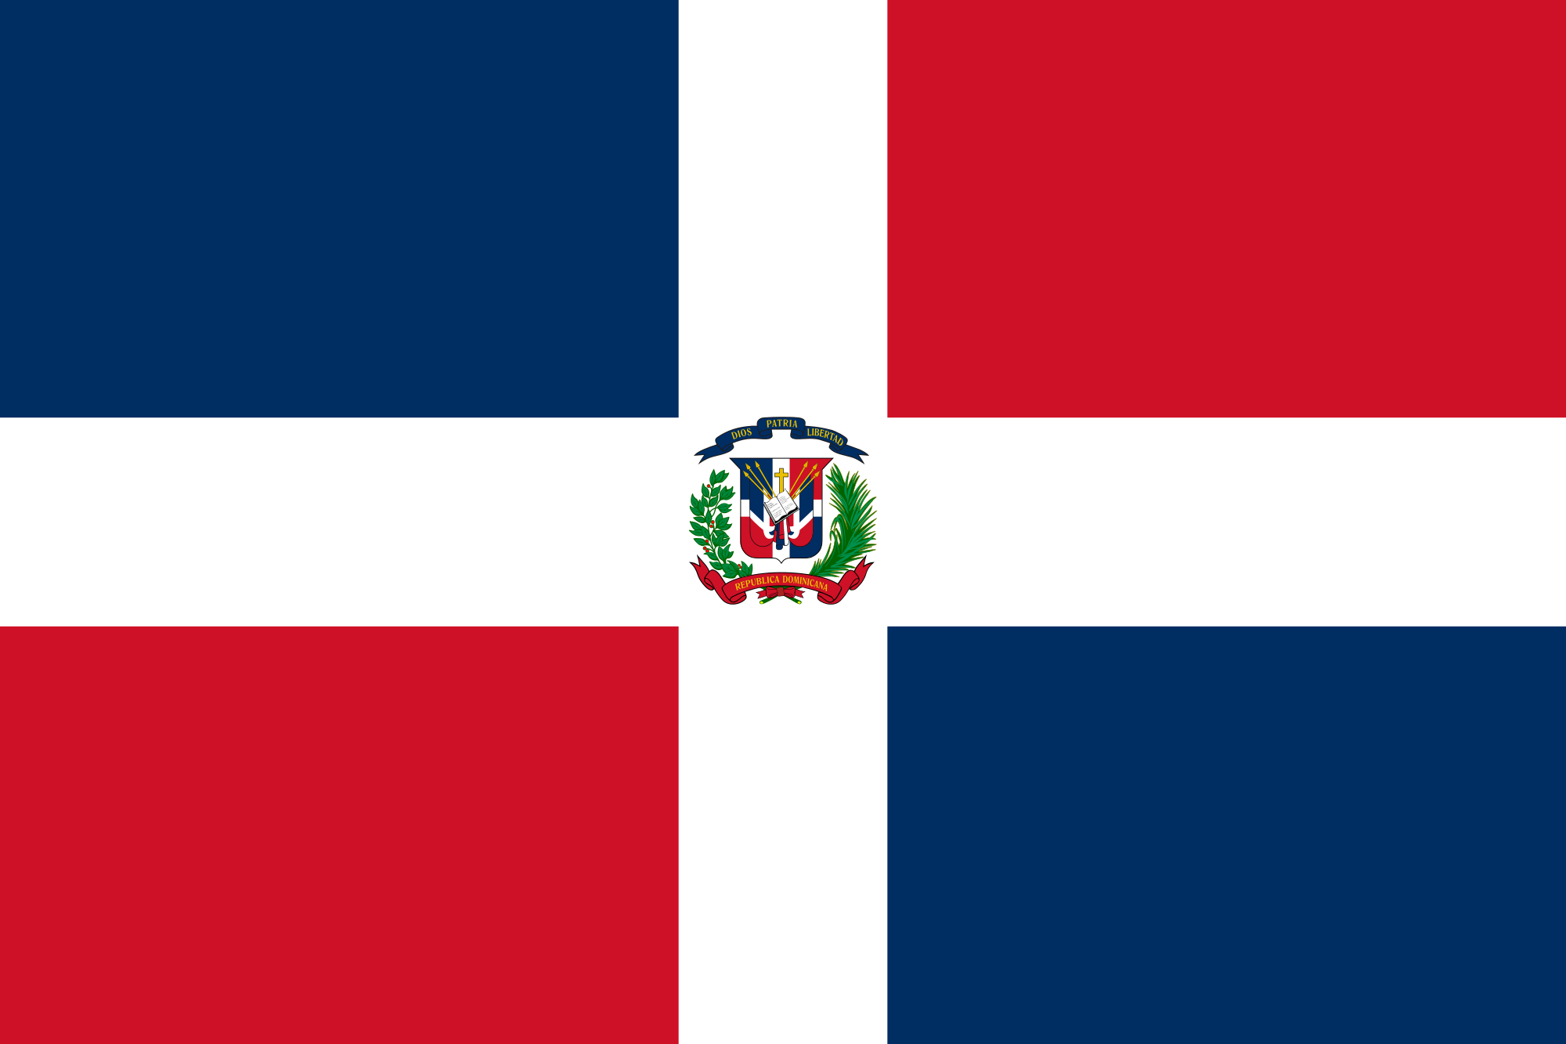República Dominicana
Published a report about the work of Observatorio Ciudadano al Financiamiento Político de Participación Ciudadana [Citizen Observatory for the Political Funding of Citizen Participation], who warned of the absence of transparency and the limited Access of information in the political parties. Ver más

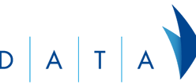
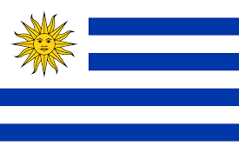Uruguay
Continued carrying out work from 2011, in the Oktober DATAFEST on October 17, DATA presented a new Hackaton, where groups of developers, designers, researchers and journalists work together to create apps that serve to resolve social problems. Ver más

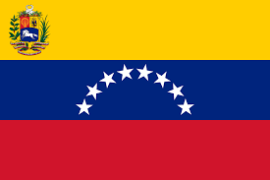Venezuela
On October 19th Transparencia Venezuela published a report on the “Situation of the right of freedom of expression in Venezuela before the CIDH.” Ver más

