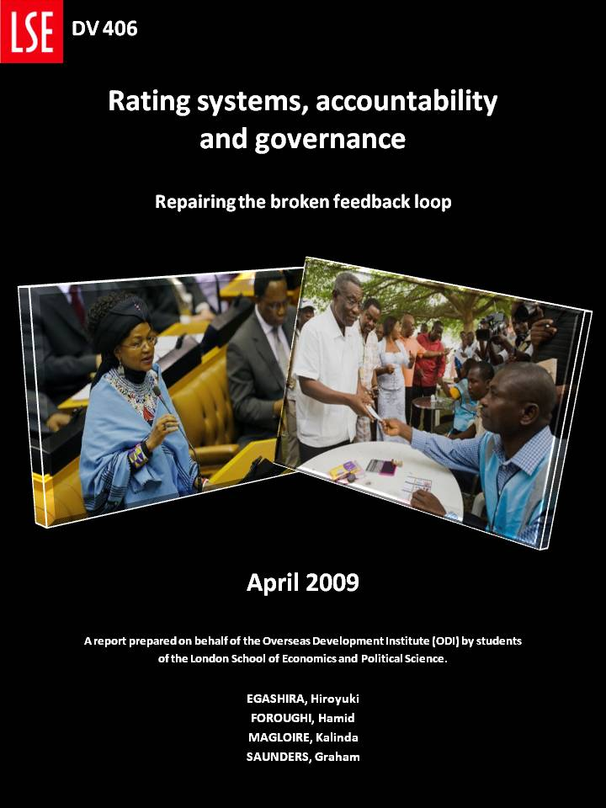

**Executive Summary**

**Executive summary**

The purpose of this scoping research is to explore innovative ways to enhance governance in countries where accountability mechanisms and the links between citizens’ preferences and government action are weak. We believe that enhancing these mechanisms and links are essential to good governance, which is itself crucial to eradicating poverty and ensuring sustainable development. Good governance is characterized by well informed citizens holding decision-makers and service providers accountable. In essence, a feedback loop is created between citizens and their rulers, where preferences are heard, government policies enacted, and the outcomes—policies, service delivery, etc—are evaluated by citizens. These evaluations may then incentivize rulers to design and implement further policies in alignment with citizen’s preferences. However, in many cases where citizens do not have access to clear information on government activities, this feedback loop is often broken. In these contexts, information on government activities is usually non-existent, biased, or fragmented, making it very difficult for citizens to evaluate government actions. Thus there is a strong need to explore possible mechanisms to repair this broken feedback loop. Rating systems, by evaluating government performance, provide citizens with relevant information, which may in turn incentivize rulers to act in convergence with citizens’ preferences. Such initiatives could strengthen accountability between rulers and citizens, improve the performance of MPs, parliaments, budget processes and service delivery, and therefore improve the nature of governance. Thus, the purpose of this report is to explore different attempts at repairing broken feedback loops through rating systems.

Rating systems applied in contexts of weak governance often concentrate on three areas of governance - legislative processes, budget processes and service delivery. Each of these three areas is crucial to poverty alleviation. But since the latter—service delivery—has been thoroughly documented in other studies we have chosen to concentrate solely on legislative and budget processes. The report presents a literature review on governance, accountability and rating systems, followed by an overview of six case-studies of rating systems. We have attempted to provide a representative and broad sample of initiatives both in terms of area of expertise and geography. Cases are selected from contexts as diverse as Pakistan and Japan, South Africa and Tanzania, and Argentina and Philippines. In order to come up with a standardized view of these different initiatives and to facilitate comparison between them, we have designed an analytical framework that will be applied to each case and provide pertinent information on background, objectives, recipients, impacts, costs, constraints, uncertainties, trade-offs and unintended consequences. It is important to note that the purpose of this study is not to provide an in depth analysis of all the components of these rating system initiatives, nor to provide a full evaluation of their effectiveness. Instead, we hope to make preliminary assessments of these initiatives and to a certain extent, to provide recommendations for future initiatives rating MPs, legislative processes and budget processes.

We have identified some key issues crucial to the success of these initiatives and their possible replication. Among them are: the right of access to information, relationship with the media, partnerships with MPs, funding and project’s independence, qualitative versus quantitative data, value and accuracy of data, importance of networks, citizen involvement, scaling up, and lastly, incentives, impact and evaluation. This preliminary research shows that most of the initiatives have had mixed success in providing citizens with sound information, which would theoretically allow them to make informed decisions about their rulers. Therefore, finding adequate solutions to these key issues might improve project impact and provide a better framework for scaling up. For example, we offer that these initiatives might benefit from better engagement with media outlets in their efforts at information dissemination. We also offer that good collaboration with MPs and legislatives structures may prove crucial in avoiding MP suspicion and reluctance towards these initiatives. Perhaps most important, our preliminary research found that there is little proof of behavior change as a consequence of the new available information. This raises the very important issue of enforceability. Indeed, if the mechanisms to sanction rulers are not available or well functioning then the relevant information provided by the rating systems cannot be translated into incentives, which are necessary to facilitate real behavior change. This problem suggests that rating systems should be integrated in a larger set of initiatives that aim at improving all aspects of the feedback loop such as the right to information, free and fair elections, strong political parties, competition in service delivery, etc. The most tangible impacts observed concern mostly the reinforcement of the right to information and changes in the political culture. These types of improvements, at the current stage, might be more realistic measures of success than the actual creation of incentives that would motivate rulers to align their actions and decision-making with citizen’s preferences.

**Keywords: rating systems, accountability mechanisms, good governance, pro-poor governance, incentives, legislative processes, budget processes.**

**TABLE OF CONTENTS**

Executive summary 1

Acknowledgements 4

List of figures 5

Abbreviations 6

i Introduction 7

II LITERATURE REVIEW 8

Good Governance 8

Accountability and Good Governance 9

Information, incentives and vertical accountability 10

The Role of Rating Systems in Promoting Accountability 11

Primary Characteristics of Rating Systems 11

Ensuring Accountability in Legislative Processes, Budget Processes, and Service Delivery 12

III METHODOLOGY 13

IV Initiatives RATING MPS AND LEGISLATIVE PROCESSES 15

Kokkai Giin Hakusyo Whitepaper on MP*s* (japan) 15

directorio legislativo (argentina) 17

fafen: parliament watch project (pakistan) 19

V INITIATIVES RATING BUDGET PROCESSES 21

Textbook Count (philippines) 21

Participatory Monitoring of PRS and Pro-poor expenditure (tanzania) 23

Institute for Democracy in South Africa – Economic Governance Programme (egp) (south africa) 25

VI CONCLUSION 27

**Bibliography 31**

**appendix 33**

Appendix 1 Congreso visible (colombia) 34

Appendix 2 Parliamentary Scorecard: Assessing the Performance of Uganda’s Legislators (uganda) 36

**Acknowledgements**

This research project is an assignment for the Development Management Course at the London School of Economics and was prepared for the Overseas Development Institute (ODI).

Alan Hudson, Research fellow at the Overseas Development Institute elaborated the terms of reference for this research and provided us with useful guidance, feedbacks and information.

During the course of developing this work, many teachers of the Development Studies Institute (DESTIN) of the London School of Economics also gave us insightful feedbacks.

We are grateful to many people working with Congreso Visible, Directorio Legislativo, FAFEN, Kokkai Giin Hakusyo, Uganda Parliamentary Scorecard, Textbook Count Project, Tanzania Participatory Monitoring project and IDASA for the useful information they provided and their availability to answer our questions.

**LIST OF FIGURES**

**Figure 1- The broken feedback loop 9**

**Figure 2 – Rating Systems: repairing the broken feedback loop 11**

**Figure 3 – Output of the rating system (Japan) 16**

**Figure 4 - Output of the rating system (Argentina) 17**

**Figure 5 – Number of members who raise CANs by party 19**

**Figure 6 - Sample IDASA Budget Brief 25**

**Abbreviations**

**CSO Civil society organisation**

**CV Congreso Visible (Colombia)**

**DFID Department for International Development (UK)**

**EGP Economic Governance Programme (South Africa)**

**FAFEN Free and Fair Election Network (Pakistan)**

**IDASA Institute for Democracy in South Africa**

**MNA Members of the National Assembly**

**MP Member of Parliament**

**MPA Members of the Provincial Assembly**

**OECD Organisation for Economic Co-operation and Development**

**PIMA Measurement card in Swahili**

**PMMP Poverty Monitoring Master Plan**

**PRSP Poverty Reduction Strategy Paper**

**PTF Partnership for Transparency Fund**

**ROLE Rule of Law Effectiveness**

**TAF The Asia Foundation**

**UNDP United Nations Development Programme**

**USAID United States Agency for International Development**

1. **Introduction**

This piece of scoping research is based on the belief that effective states and good governance are essential to combat poverty. Institutional frameworks based on good governance provide mechanisms for well-informed citizens to hold decision-makers and service providers accountable and by the same token provide them with the right incentives to align their decisions and actions with citizens’ preferences (DFID 2006: 26). These mechanisms are essential for an effective institutional framework for poverty alleviation. Indeed, one can say that what is valid for good governance is as true for pro-poor governance. In our understanding, pro-poor governance is good governance where the group holding the rulers accountable is the poor. Consequently we will concentrate on the different elements and dynamics indispensable for good governance in general, with the assumption that they can be applied to pro-poor governance as well. In any case, unless these accountability mechanisms are present and functioning adequately, technical solutions for poverty reduction will likely remain superficial and ineffective.

In order to hold policy makers and service providers accountable, citizens need information in order to be aware of the commitments taken by their government. With this information, citizens may then be able to assess if these commitments are aligned with their interest and secondly, if these commitments are being respected. Theoretically, in a democratic regime, discontented citizens can sanction their government through elections and this capacity of sanction provides the government with the necessary incentives to comply with citizens’ demands. We can thus see that the possibility of sanctions, information and incentives are crucial elements to accountability mechanisms. Information provided to citizens is often sporadic, scarce and incomplete; furthermore the channels available for citizens to provide feedback are very rare and ineffective. Our goal is to contribute to the discussion on how to rectify these shortcomings. We will do that by looking at rating system initiatives. These rating systems provide citizens with relevant information, and through that, can help repair the broken feedback loop between citizens and rulers. For example, rating system initiatives concerned with budgetary and legislative processes produce an analysis and translate overly technical formulations into clear facts that citizens can understand and assess in terms of their own interests.

Before we explore the initiatives, we will explain the different concepts at stake. We will first describe the overarching framework of good governance. We will then present a definition of accountability and its importance for good governance. We will finally show the importance of information and incentives for accountability mechanisms and how rating systems can be useful tools to improve their quality. After this brief literature review, we will explain the methodology used to categorize and review the initiatives.

1. **LITERATURE REVIEW**

**Good Governance[1]**

Governance, generally speaking, can be defined as “the formal and informal processes through which a society’s rules are established, operate and evolve […] the foundation of governance is therefore politics, […] all activities involved in the use, production and distribution of resources, […] [and] the ongoing processes of social and political bargaining that results from individual and group interests” (O’Neill *et al* 2006; 1).

Theoretically, democratic governance has certain accountability mechanisms built in such as political parties, referendums, and perhaps most importantly, elections, which serve to ensure that national policy and political processes continue to reflect the needs and desires of the country’s citizens.

Good governance entails effective accountability and incentive mechanisms between citizens and national institutions (federal/local government, parliament, etc.). It also includes attributes of “responsiveness, inclusiveness, participation, integrity and accountability” (Khan 2004, 5). Importantly, it is argued that only with sufficient *information* will citizens be able to demand true accountability from their governments, and that only through an accountable government responding to certain *incentives* from its polity, will national policy reflect the needs and wishes of the citizenry. The turn to governance issues in the development literature came from the assessment that technical solutions are largely insufficient to trigger substantial changes, and that “institutions are crucial to promoting development, and responsive, effective and accountable states are deemed to be a critical hinge in achieving the transformations necessary…” (Rocha Menocal and Sharma 2008; 15).

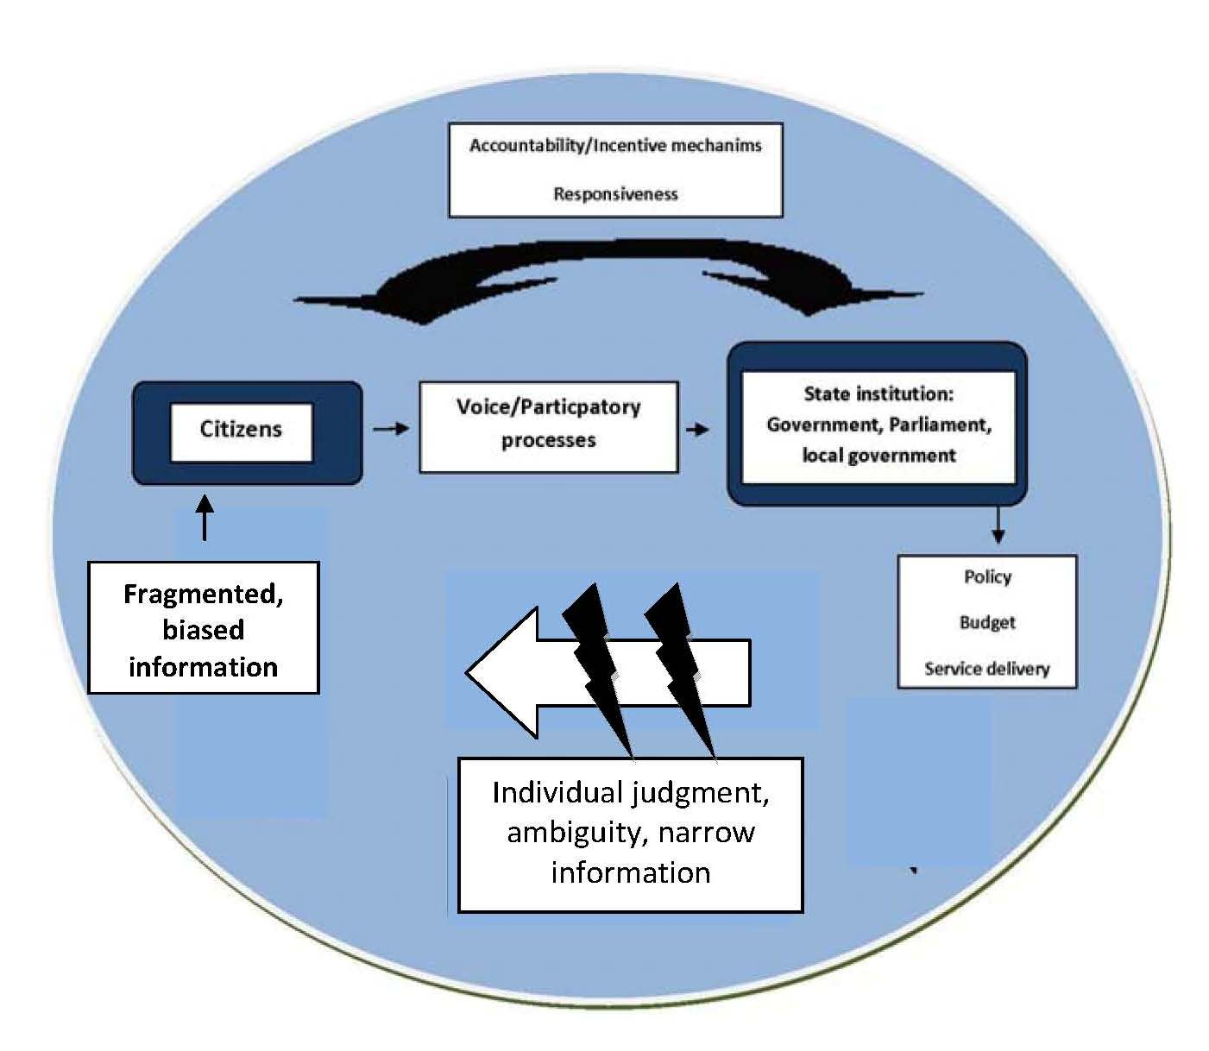

**Fragmented**

**Information**

Individual judgment, ambiguity, narrows information

Figure 1-The broken feedback loop

**Accountability and Good Governance**

Accountability is a core element of any good governance framework. One recent paper offers that “governments or states that can be held accountable for their actions are more likely to respond to the needs and demands articulated by their population” (Rocha Menocal and Sharma 2008, vi). It is important to introduce now a clear definition of accountability. Firstly, accountability entails “a relationship between two parties, those who set or control the application and implementation of the rules, and those who are subject to the rules” (Rocha Menocal and Sharma 2008, 5). Further, “accountability exists when those who set and implement the rules…are answerable to those whose lives are shaped by those rules and can be sanctioned if their performance is unsatisfactory” (O’Neill, et al. 2007, 1). Some elements are indispensable for accountability mechanisms to function properly. These core elements are: **transparency, answerability and enforceability** (OECD GOVNET 2009). *Transparency* implies the capacity to collect information and make it accessible for citizens’ scrutiny. *Answerability* entails that rulers have the obligation to provide justifications for their actions when questioned by citizens. Finally, *enforceability* concerns citizens’ capacity for imposing sanctions for the shortcomings between the commitments taken and actual results (in terms of government policy and service delivery). (OECD GOVNET 2009; Weisband and Ebrahim 2007).

The main forms of domestic accountability are *vertical accountability* and *horizontal accountability*. Vertical accountability concerns accountability relationships directly between the citizens and their national government, and its most obvious example comes in the form of regularly held elections. Horizontal accountability, on the other hand, generally concerns the national government itself, involving certain mechanisms or “checks and balances” between the different governmental branches (i.e.: executive, legislative, and judicial).

Elections are often viewed as the only channel for vertical accountability; however, in this report we use vertical accountability in a broader sense that encompasses all the mechanisms that allow citizens to hold policy makers and service providers accountable. Citizens have been encouraged to engage directly in initiatives enhancing accountability such as participatory budgeting, administrative procedure acts, social audits, and citizen report cards. This broader definition of vertical accountability is also referred to as hybrid accountability or diagonal accountability (Goetz and Jenkins 2005). It also relates very closely to the concept of social accountability used by the World Bank (World Bank, The Public Sector Governance Unit; 3).

**Information, incentives and vertical accountability**

Broadly speaking, information for vertical accountability can be understood as relevant knowledge that may enable citizens to make informed decisions. In order for citizens to hold the government accountable and ensure that its actions are aligned with citizens’ preference, they need proper information on the commitment made by government as well as information on government performance in achieving these commitments. Broadening the narrow definition of vertical accountability, we can identify other channels for enhancing this relationship, such as written judgments, access to parliamentary committee sessions, invited participation in budgetary and policy processes, as well as media scrutiny (Rocha Menocal and Sharma 2008; 5).The relevant information given to citizens and their feedback on it can provide the decision makers with the incentives to change behaviors.

Oftentimes, citizens lack crucial information on performance or government policy. As Keefer and Khemani point out, there are various “constraints” facing people in obtaining relevant knowledge, particularly for those in poverty. They explain, “broad sections of the poor population might be particularly disadvantaged in accessing information, because of illiteracy, limited mobility, and underdeveloped media for mass communications” (Keefer and Khemani 2003; 8). Many of the initiatives and mechanisms introduced to promote vertical accountability and civil society engagement in policy processes, including citizen report cards, participatory budgets, and social audits, serve to make up for this information gap.

In that context, rating systems can be seen as another type of intervention to improve accountability and therefore good governance by providing relevant information that may in turn produce real behavior change.

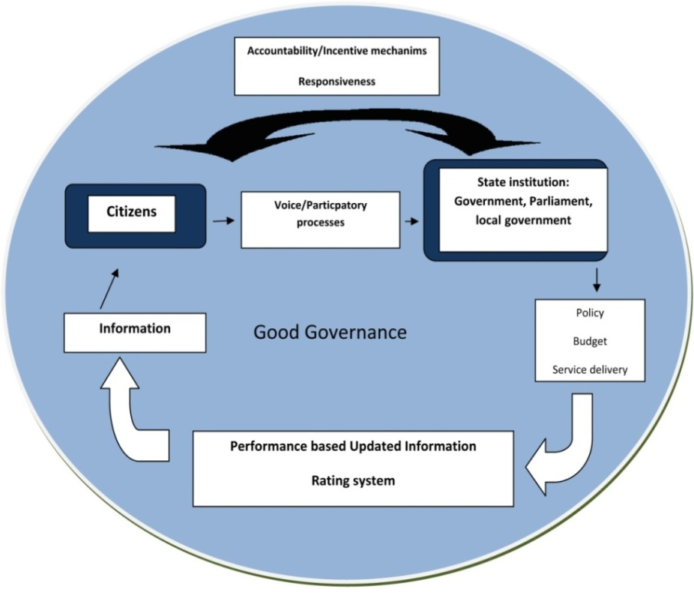

**Figure 2 – Rating Systems: repairing the broken feedback loop**

**The Role of Rating Systems in Promoting Accountability**

A rating system can be defined as a “system of measuring, recording, collecting, aggregating, analyzing, communicating and acting with the explicit purpose of improving performance” (Society for Participatory Research in Asia). Rating systems provide relevant information to citizens on government performance in an attempt to repair the broken feedback loop between citizens and rulers. This process aims to alter the incentives of rulers and ultimately promote real behavior change. In the following section, we present the primary characteristics of rating systems.

***Primary Characteristics of Rating Systems***

We can understand a rating system as an attempt to present a picture, either implicitly or explicitly, of a desirable situation and to provide information to the extent of the shortcomings towards this ideal goal. Hence, they provide relevant information, which may in turn incentivize for actions on the gaps between citizens preferences and actual results. A successful rating system creates identifiable—and oftentimes quantifiable—indicators to present results and each of these indicators must have an “owner” taking responsibility for it (in our case, MP, Parliament or actors involved in the budget process). A rating system can thus be considered an accountability mechanism that provides incentives to the rated target, which oftentimes can come through opportunities for penalization for poor performance and reward for good performance. Fundamentally, a rating system attempts to present clear and understandable information that will hopefully lead to real behavior change on the part of both parties to the accountability relationship.

Given the necessity to increase and improve channels of vertical accountability and because of the lack of research on governance initiatives involving rating systems, what we present here is an analysis of several initiatives that fit the above definition. In the end, we hope to approximate some broad lessons learned and best practices from these initiatives’ experiences in attempting to increase accountability and citizen oversight.

Ensuring Accountability in Legislative Processes, Budget Processes, and Service Delivery

In recent attempts to strengthen citizen voice and vertical accountability mechanisms, we can locate initiatives that seek to provide relevant information to citizens concerning three areas of governance: legislative processes, budget processes, and service delivery performance. Each of these three areas is crucial to poverty alleviation. Information on *legislative* processes generally concerns parliaments and representative performance. Little work has been done to measure the performance of parliament in relation to clear governance criteria. A focus on parliament is important because of its role in designing national laws, and therefore “it is paramount that the people and their representatives are offered the opportunity to make inputs” in the legislative process (Cobbina 2006; 5). Theoretically then, if conventional vertical and horizontal accountability mechanisms are weak in a country leading to inadequate national policies, providing information on the policy making process in the legislature and on specific MP’s performance would seem to allow for a more informed citizenry. And as long as certain channels exist for citizens to translate this knowledge into incentives for their government, stronger accountability between the legislature and the people would seem to follow.

Equally important for good governance is accountability within the context of the national *budget*—what Schumpeter called the “skeleton of the state stripped of all misleading ideologies” (Brautigam 2004). In theory, the national budget “fulfills a number of critical functions including: allocation of resources to priority sectors; the distribution of wealth and incomes and fulfilling and adhering to pre-determined macro economic targets” (Cobbina, 2006; 6). We can see then the potentially crucial role the national budget can play in ensuring good governance, and thus the strong need for civil society engagement with the budget-drawing process.

Lastly, certain information concerning *government service delivery* can be disseminated in efforts to promote vertical accountability. Citizen report cards are being employed more and more in efforts to give feedback to government service providers on their performance. As a World Bank report notes, service users filling out report cards “know better than anyone else how responsible or reliable an agency is or what are the costs attached to a service” (World Bank 2004a, 1). The underlying notion in citizen report cards echoes the primary goal of the other efforts at strengthening vertical accountability in legislative and budgetary processes—that of promoting accountability by giving the citizens a channel to provide their inputs and repair the broken feedback loop between citizens and service providers.

In this report, we will concentrate only on rating systems concerning MPs, legislative processes and budgetary processes because a lot of work has already been conducted on systems rating service delivery. The case of rating systems for service delivery is quite different from systems rating legislative processes or budgetary processes. In fact, in the case of citizen’s report cards, citizens are not receiving information from anyone; instead they are providing their feedback on their personal reality and their evaluation of the service providers’ performance. In contrast, systems rating legislative or budgetary processes are most of the time carried out by professionals from civil society organizations, with a certain expertise to evaluate and assess the processes in question.

1. **METHODOLOGY**

Based on the definition of rating systems developed earlier, we have identified a set of criteria providing a framework to identify rating system initiatives. These criteria can be listed as follows:

* There exists a prior relationship of (weak or strong) accountability between two parties
* The rating system provides a picture of a desirable situation, either implicitly or explicitly
* The rating system provides relevant information through specific indicators on the potential gaps between reality and the desirable situation
* There can exist mechanisms of potential penalization for poor performance and reward for good performance

Generally speaking, using rating systems as a mechanism of accountability is a relatively new phenomenon. The initiatives in this area are scarce and the ones that exist are very recent. In this study we have chosen to focus on the evaluation of initiatives rating democratically elected MPs, legislative processes and budget processes.

In the following section, six projects meeting the above criteria will be presented. We have also tried to provide a representative and broad sample of initiatives both in terms of geography and area of expertise. For the background research we have reviewed more than a dozen of projects, for the sake of conciseness, we have limited to six the number of projects presented in the core of the document, however two others will be placed in the appendices for those interested in additional information. The review will be divided into two sections: in the first section we will present three applications of rating systems for MP performances and legislative processes. The second section will review three other rating systems for budget processes.

The purpose of this study is not to provide an in depth analysis of all the components of rating system initiatives but rather to provide a broad overview of different possibilities experienced in this area. In order to come up with a standardized view of different initiatives and to facilitate comparison we have designed an analytical framework that will be applied to each case. This analytical framework is structured as follows:

|  |  |
| --- | --- |
| I | **What is the project’s background?** |
| II | **What are the objectives of this project? Who and what does it rate? Who are the recipients of the information collected?** |
| III | **What assessment can be made of the project?**  **a) What is the project’s impact?**  **b) What is the cost of the project? Is it sustainable? Is it involved in partnerships with other organizations?**  **c) What are the constraints, uncertainties, trade-offs and unintended consequences?** |

Through these case studies, we hope to make preliminary assessments of these initiatives, and to a certain extent, to provide recommendations for future initiatives rating MPs, legislative processes and budget processes.

1. **INITIATIVES RATING MPS AND LEGISLATIVE PROCESSES**

**Kokkai Giin Hakusyo *Whitepaper on MPs* (JAPAN)**

I **What is the project’s background?**

In general, citizens tend to lack information on activities of MPs in the parliaments and they rely on news provided by mass media. Therefore, they are often influenced by exaggerated information which focuses on political conflicts, particular incidents or politicians’ declarations. The end result is that in many cases citizens do not seem to be able to evaluate politicians properly (Japan Internet News, 2008).

II **What are the objectives of this project? Who and what does it rate? Who are the recipients of the information collected?**

Kokkai Giin Hakusyo is an online database system. This site was developed jointly by Japan Internet News Co, Ltd. and Dr. Sugawara who is an associate professor of Tokyo University. This system is operated by Japan Internet News Co, Ltd, while data is provided by Dr. Sugawara. The main aim of this system is to collect objective data of different activities of MPs and provide citizens with the data in a way that one can access easily. This rating system tracks the activities of Japanese parliament members of both the House of Representatives and the Upper House. The activities to be rated are: the number of private member’s bills, memoranda on questions, attendance at committees, and remarks at committees (Japan Internet News, 2008). The recipients of this information collected are: citizens (mainly who are granted suffrage in Japan), politicians, mass media, and academic researchers.

**III What assessment can be made of the project?**

**a) What is the project’s impact?**

This rating system can be accessed through the Internet. Given that the prevalence rate of the Internet in Japan in 2007 was 69% (MIAC, 2008), it can be available among a large part of the population. Its user interface of the rating system is fairly simple and easy to use. Some useful functions are equipped. For example, relevant information such as web sites of MPs can be accessed through the links provided by search results. These functions enable users to access and analyze them at a minimum effort. This makes positive impacts on users because it is difficult for ordinary citizens to locate or collect relevant data as these are stored in various places or web sites.

The project is relatively recent and therefore it is still difficult to assess the outcomes. Citizens can obtain information concerned with political activities in the parliament. Therefore, they would pay more attention to political issues and some might want to evaluate by themselves. Politicians may then feel pressure from citizens and then value their activities in parliament more.

**b) What is the cost of the project? Is it sustainable? Is it involved in partnerships with other organizations?**

Japan Internet News covers the cost of running this system. This company operates Japan Alternative News for Justices and News (JANJAN), which has been playing a pioneering role in Internet journalism in Japan. This project is one of the components of JANJAN. The scale of the company is relatively small but retired-prominent figures in various sectors such as mass media, industry and the government serve as executives of the company (Japan Internet News, 2008). In addition, as mentioned above, the basic data of this project has been provided continuously. Given these facts, this project could be expected to be sustainable.

**c) What are the constraints, uncertainties, trade-offs and unintended consequences?**

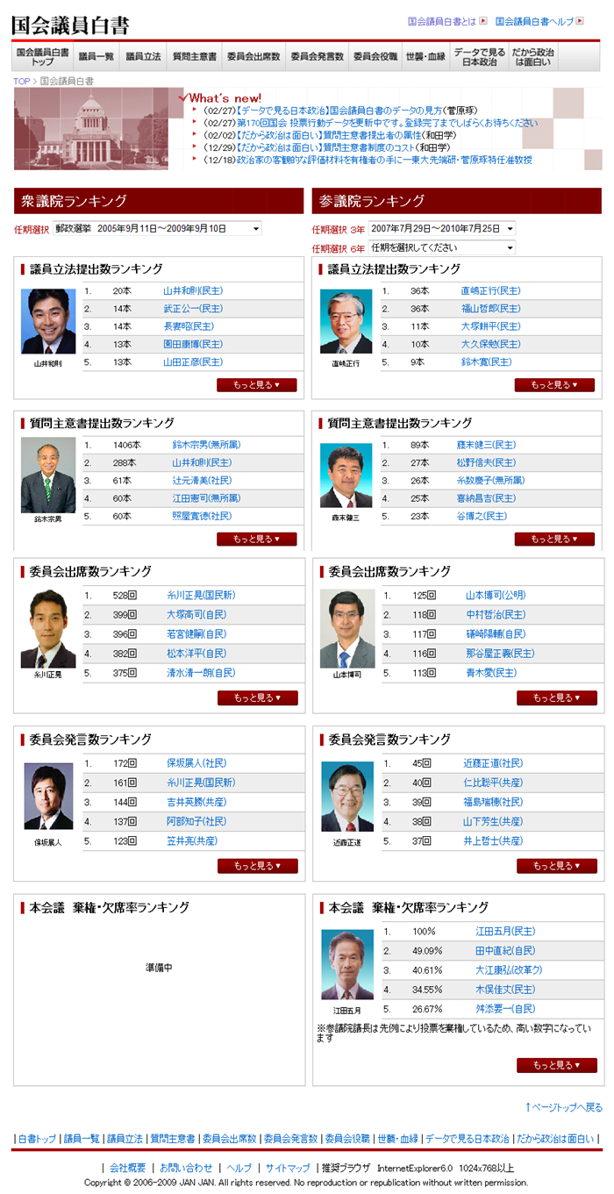There are several constraints facing this project. First, this system needs to include more useful functions such as summing data by parties and types of data, or more sophisticated search capacities. However, developing these functions cannot be implemented within the budget constraint. Secondly, for some parties, the data might be biased. For example, under the Japanese parliament system, ruling parties tend neither to use memorandum on questions nor to make members’ bills private. In this case, the data does not necessarily reflect the real activities of MPs in ruling parties. Thirdly, the types of collected data are limited. The system needs to increase them so that citizens can evaluate politicians from different aspects (Japan Internet News, 2008). Fourth, this system completely depends on the Internet. This means that it might not benefit those who live in remote villages where the Internet is not available. Also, one potential source of unintended consequences might be the risk of erroneous data.

Figure 3 – Output of the rating system (Japan)

***For more information on this initiative, you can visit:***[***http://www.senkyo.janjan.jp/diet/dietinfo/***](https://exchange.lse.ac.uk/exchweb/bin/redir.asp?URL=http://www.senkyo.janjan.jp/diet/dietinfo/)

**Directorio Legislativo (ARGENTINA)**

**I What is the project’s background?**

This project works on the basis that the right of access to public information already exists and is secured through the international treaties signed by Argentina and incorporated into the Constitution with constitutional reform in 1994. Therefore the DL team collected information on the premise that the rights must be exercised.The personal websites of legislators are far from being updated and many of them still refuse to answer on who they are and what they do. Regulations governing the internal activities of both chambers are not public. Nor is the organization of the chambers, i.e. the basic structure of the body, their tasks, and hierarchical structures. The internet publication is insufficient. The nominations of employees, their wages and tasks are published only partially. Moreover, the prohibition of the free entry of cameras inside the buildings of the Congress inhibits and impedes citizen participation in committee meetings and plenary sessions.

II **What are the objectives of this project? Who and what does it rate? Who are the recipients of the information collected?**

The "Directorio Legislativo" is a biannual initiative created in 1999 using the right of access to public information to create a tool that contains among other things, the legislators' personal information, details of parliamentary work, and contact information. This is a product of joint effort between civil society and its legislators, given that the information contained in its entirety has been provided directly by the legislators themselves, their counselors, secretaries and staff of the National Congress.

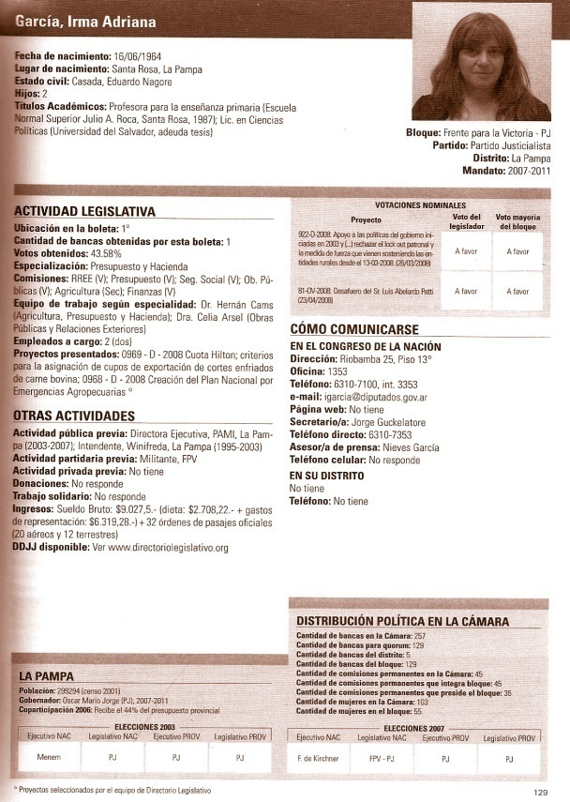The target population for the information collected is the legislators and the general public. The legislators are a major target since this is a joint initiative between civil society and the Parliament. The legislators who give their information have to confirm the authenticity of the information given before publication. The impact of the publication on them can be measured by the amount of information they are willing to give the next year. 329 legislators and approximately 200 officials of Parliament receive the publication. This process creates a multiplying effect since thousands of people have access to these WebPages. The publication is also sent free of charge to a database of 10,000 people (CSOs, academics, students...) with among them approximately 300 hundred journalists, who in turn make the public aware of the available information. The Directorio Legislativo team also writes at least 10 articles for newspaper or magazines of mass circulation after each publication. Figure 4 - Output of the rating system (Argentina)

**III What assessment can be made of the project?**

**a) What is the project’s impact?**

Directorio Legislativo’s objectives are on a long term basis however they consider that there have been important signs of success. In 1999 the actors involved in the process, including the first Mps interviewed, assured the project initiators that this project would be impossible to achieve given the practices of Argentine politics. From 1999 until now there have been five editions of the Legislative Directory. With each edition they have been able to provide more information, (1st edition 316 pages, 4th edition 473 pages). They also expanded their sphere of action to three other districts (Legislature of Buenos Aires, Mendoza and Legislature of Buenos Aires). (Directorio Legislativo website)

After 8 years, the Directorio Legislativo has gained credibility inside and outside the Parliament. It is a very important gain as the legislators’ trust is crucial for the process. Along the past years, more and more legislators progressively provide the information required by the publication (the first years, 30% of legislators did not agree with releasing their personal and professional information. For the last edition, more than 90% responded positively to requests).

The organization, through a volunteer’s campaign, forced legislators to comply with the National Public Ethic Law that requires the publications of legislators’ financial statements.

**b) What is the cost of the project? Is it sustainable? Is it involved in partnerships with other organizations?**

For the realization of this project, funds are only one part of the needs. The commitment of various actors, mainly the legislators themselves is indispensable. Thus the necessity to have an “education” component in the project to sensitize the MPs. Financing is also a big issue, the University of Congress reduces the fees of its students so that they can work for the Legislative Directory as a volunteer to talk with lawmakers and advisers. Another partner is the CIPPEC Foundation, who supports the project financially but also provides administrative and institutional assistance. Thus, Directorio Legislativo can use their office resources such as computers, telephone, fax, photocopy etc.

The initiative is financed through funds from local and international organizations. The Directorio Legislativo does not generate profits because their product is delivered free of charge to the recipients. The long-term goal is for the Legislature to finance the project itself. Until then they rely on outside donations. (Baron, M and N.A. Murray 2008)

**c) What are the constraints, uncertainties, trade-offs and unintended consequences?**

The biggest challenge in terms of expanding is financial. International cooperation is increasingly restricted and the project needs more funds. The people trained for each of these initiatives need work stability and in such projects, this is very difficult to achieve. Therefore, it happened many times that at the beginning of a new directory, new staff had to be trained all over again because of the lack of capacity to retain formerly trained staff and therefore to capitalize on the knowledge built in the past years.

***For more information on this initiative, you can visit:*** [***http://www.directoriolegislativo.org/***](http://www.directoriolegislativo.org/)

**FAFEN: Parliament Watch Project (PAKISTAN)**

I **What is the project’s background?**

Tense political situations in Pakistan have created difficult conditions for political activists. Moreover, the media is overwhelmed with incidences that divert public attention from real parliamentary performance. To fill this gap, FAFEN initiated this project in 2008.

II **What are the objectives of this project? Who and what does it rate? Who are the recipients of the information collected?**

The main aim of this system is to foster more informed engagement between constituents and elected representatives in Pakistan by providing objective and statistically-sound information on parliamentary processes and decisions. For this purpose, FAFEN collects and publishes information about the performance of Members of the National Assembly (MNAs) and Members of the Provincial Assemblies (MPAs) by observation of these directly elected representatives’ actions in the legislatures.

The activities rated are:

* Member Participation,
* Number of MNAs who applied for leave,
* Number of Calling Attention Notices (CANs),
* Number of Points of Order raised by each parliament member

Figure 5 – Number of members who raise CANs by party

The results of these criteria are published for each party and not for each individual MP.  The recipients of the collected information are citizens, politicians, mass media, and academic researchers. Periodic Reports (for each session of national assembly) are available on the FAFEN website.

FAFEN’s rating system is based on observation conducted by the Center for Peace and Development initiatives.

**III What assessment can be made of the project?**

**a) What is the project’s impact?**

Updated versions of the report can be accessed on the Internet. Since the information is based on direct observation, the data published in these reports are reliable. Moreover, it reveals information that cannot be accessed through other sources. The project recently started in November 2008, and thus it is difficult to make an assessment. However some issues may be raised. Since the report addresses the indicators for each party, performance of individual MPs, it seems, is not measurable. Moreover, it may be difficult to compare the performance of each party because each party holds a different amount of seats in parliament.

**b) What is the cost of the project? Is it sustainable? Is it involved in partnerships with other organizations?**

FAFEN is governed by Trust for Democratic Education and Accountability and the information gathered for this report are based on observation conducted by Center for Peace and Development Initiatives.

**c) What are the constraints, uncertainties, trade-offs and unintended consequences?**

This system needs to employ more useful functions such as presenting data for each individual MP. The present system rates each party, but since the number of seats held by each party varies, the results are hardly comparable. In the extreme case, one party holds 31 seats while another party holds only one seat. In this situation neither the absolute number of participation nor the relative figure will be a good indicator for comparing different parties. And further, these data might actually foster indicator driven behavior from the MPs.

Rating should be extended to the content of legislation and/or other parliamentary activities to make sure that MPs are aligning their work with their constituents’ preferences. Furthermore, since the criteria for rating MPs are quantitative (“number of members, making motion,” etc.), it is possible that MPs may increase their apparent activity, without actually improving the effectiveness of parliamentary processes.

***For more information on this initiative, you can visit: http://www.fafen.org/v1.fafen/***

1. **INITIATIVES RATING BUDGET PROCESSES**

**Textbook Count (PHILIPPINES)**

I **What is the project’s background?**

In the 1990s, The Department of Education (DOE), which is in charge of the education service for approximately 18 million students, was criticized due to proliferating corruption. In particular, the procurement of textbooks delivered to students for free under the nation’s law was seen as a primary cause of the corruption. Given the problem, Government Watch (G-Watch), an anti-corruption initiative which has been involved in monitoring various public services since 2001, launched a program focusing on the procurement process of textbooks, called “Textbook Count Program”. Four rounds of the program were implemented between 2003 and 2007 (Ramkumar, 2008; Government Watch, 2007).

II **What are the objectives of this project? Who and what does it rate? Who are the recipients of the information collected?**

The Textbook Count Program was led by G-Watch collaborating with various forms of civil society organizations such as the National Citizen’s Movement for Free Elections, the Transparency and Accountability Network, the Boy Scouts and Girl Scouts, as well as some religious organizations. Every year between 2003 and 2007 G-watch and CSOs cooperated in monitoring the procurement process of more than one million textbooks. The CSOs monitored the bidding, the production of the textbooks and the delivery, while G-Watch mainly supported the CSOs by teaching them the tools and methods of the project, while also helping them to establish relationships with the government departments. In the bidding process, they examined the complete document provided by DOE which covered each process of the tender, bidding and awarding of contracts. As for production, an inspection team comprising of members from the government departments and CSOs checked the quality of textbooks. Finally, in the delivery, the volunteers of the program obtained the allocation list and schedule ahead of the delivery so that they could monitor whether the delivery was made along with the initial plan. In addition, all stakeholders such as officers of DOE, suppliers of textbooks and the CSOs attended the post-delivery evaluation to conclude each round of the program (Ramkumar, 2008; Government Watch, 2007).

**III What assessment can be made of the project?**

**a) What is the project’s impact?**

This program had a significant impact on the procurement process of textbooks and therefore greatly benefited the students. Thanks to the International Competitive Bidding, which DOE applied under this program, the cost of purchasing textbooks reduced by approximately 50%. Defective textbooks were detected and replaced. For example, in the fourth round of the program the inspection team detected that almost all of the textbooks in a district, Daewoo, were labeled incorrectly and this was rectified at the cost of the supplier. As well, the length of the entire process of procurement from bidding to delivery was shortened from two years to one year. False deliveries were also eradicated. Lastly, another impact of this program was its positive externality, whereby the model of this program was applied in the procurement of other public services such as medicines and school buildings (Ramkumar, 2008; Government Watch, 2007).

**b) What is the cost of the project? Is it sustainable? Is it involved in partnerships with other organizations?**

G-Watch was financially supported by many private and public foreign donors: Partnership for Transparency Fund (PTF), The Asia Foundation (TAF), Rule of Law Effectiveness (ROLE), the United States Agency for International Development (USAID) and United Nations Development Programme (UNDP). A private company, Coca-Cola, also helped this program in the delivery for a part of elementary schools because DOE had financial difficulties. In addition, as mentioned above, a number of CSOs and local network groups were involved in the implementation of this program. Particularly, the Ateneo de Manila University made a great deal of contribution to the program, providing office spaces, as well as equipment and administrative services necessary for the operation of the program. In terms of sustainability, as the CSOs experienced rounds of the program, they learned more skills of the operation and gradually became more independent, which informed their local initiatives. Another important issue regarding sustainability is institutionalization. For example, DOE signed “The Department of Education Order No. 59, series of 2007” which establishes “Institutionalizing NGO and Private Sector Participation in the Department’s Procurement Process”. This would help to avoid risks of changing policy of the department and to encourage the continuity of this program (Ramkumar, 2008; Government Watch, 2007).

**c) What are the constraints, uncertainties, trade-offs and unintended consequences?**

During the implementation, those involved in this program saw some challenges. For example, while international bidding could significantly contribute to the reduction of cost, the inspection of textbooks will be difficult if the contracts were made with foreign companies. Another challenge comes from subcontracts between suppliers and forwarders. In some cases the delivery did not go as planned because sharing information was insufficient between suppliers and forwarders (Ramkumar, 2008; Government Watch, 2007).

Annually renewing partnership between G-Watch and civil organizations involved in this program tends to make the operation of this program unstable and unpredictable. In addition, leaders in both the government organizations and CSOs often change, which could undermine the continuity of the hitherto established partnership. Local social and political realities such as kinship and patron-client relations also pose a large constraint as they tend to make monitoring activities difficult (Ashoka, 2007).

***For more information on this initiative, you can visit: http://www.changemakers.net/node/737***

**Participatory Monitoring of PRS and Pro-poor expenditure (TANZANIA)**

I **What is the project’s background**

The Tanzanian government has made efforts to reduce poverty primarily through their Poverty Reduction Strategy Paper (PRSP). It also institutionalized the Poverty Monitoring Master Plan (PMMP) in response to the need for information necessary for evaluating PRSP activities and their impacts on the poor. Hakikazi Catalyst, a NGO in Tanzania which has been involved in advocating social and economic rights since 2000, decided to contribute to the PMMP for further poverty eradication (Ramkumar, 2008).

II **What are the objectives of this project? Who and what does it rate? Who are the recipients of the information collected?**

Hakikazi Catalyst conducted a participatory monitoring of the PRSP in target areas of Arusha Municipal and Arumeru Districts in the Arusha Region. Stakeholders of this project were many. In addition to the citizens involved in the participatory monitoring, the central government, local governments of Arusha Municipal and Arumeru District, the Vice President’s Office in charge of poverty eradication and CSOs were main actors in this project (Ramkumar, 2008).

Hakikazi Catalyst used PIMA card--meaning “measurement card” in Swahili—which was a modified Citizen Report card developed by the organization to monitor the PRSP. The PIMA card is different in the village and the district level. The village monitors use the village level PIMA card which measures budget allocation, the amount of funds received in the village, completion of the PRSP activities, satisfaction of the community with the activities and so forth. On the other hand, the local government officers use the district level PIMA card for the purpose of their self-evaluation of their PRSP activities. The whole process of monitoring by using PIMA card consisted of several stages. First, Hakikazi Catalyst organized workshops both at the district and community level. During the workshops, Hakikazi Catalyst selected villages to be involved in this project and provide information regarding the PIMA card. Secondly, Hakikazi Catalyst trained individuals in communities who play a major role in PIMA card process, providing participants with the skills to collect quantitative and qualitative budget information, to analyze budgets, and to present the results. Thirdly, Hakikazi Catalyst organized public debates where the cause of poverty, the strategy of poverty reduction such as targets and indicators, and purposes and benefits of PIMA card were discussed. In addition, the community members choose two target sectors to be monitored in PIMA card process. Fourth, actual PIMA cards for both the village and district level were designed. Fifth, village monitors gathered information using PIMA cards by analyzing bank statements, accounting records and receipts. Finally, at the end of PIMA card process, district officials and the communities drafted the PIMA cards reports independently, and they were peer-reviewed. The results of this project were shared not only at the community and district levels but also at the national level (Ramkumar, 2008).

**III What assessment can be made of the project?**

**a) What is the project’s impact?**

There were a number of positive impacts that resulted from monitoring the PRSP and empowering citizens. First, the grass-root monitoring activities revealed misuse of budget of the local governments, which led to the both local and central governments changing their actions. For example, a committee of Mkonoo discovered some failures of the local government where a certain amount of money was withdrawn without any records, and the roof sheets of a school were installed with lower-quality materials than those stated in the budget document. These findings encouraged the local government to investigate this problem. In addition, the central government also promised its own investigation. Secondly, participatory monitoring processes empowered citizens in terms of democratic development and capacity building. It provided citizens with opportunities to demand political accountability and also to learn methods of monitoring and evaluating the PRSP budget. With this knowledge, citizens were then able to recognize how the national plan links to the local level budget and whether the budget for the poor is disbursed along with the original plan. Thirdly, this monitoring process involved not only citizens but also the government’s staff and therefore provided a framework that encouraged dialogues between them. As well, records of these dialogues could be beneficial for citizens as a tool of negotiation. Fourth, women and men equally participated in this project, which brought awareness of the importance of the budget for the issues that tend to more concern women such as health, education and clean water (Hakizai Catalyst, 2004).

**b) What is the cost of the project? Is it sustainable? Is it involved in partnerships with other organizations?**

A part of this project was financially supported by Oxfam Ireland. In each target area, one monitoring committee, which consisted of 15 members, was established. As long as the government makes efforts to poverty reduction, the committees monitoring budgets, targets, indicators and activities of the PRSP are supposed to continue to exist (Hakizai Catalyst, 2004).

**c) What are the constraints, uncertainties, trade-offs and unintended consequences?**

First, although the Tanzanian government requires its local governments to disclose information in response to the citizens’ requests, this institutional framework worked insufficiently and, as a result, access to information remained obstacles for the implementation of the project. For example, a large part of the evidences of expenditures were difficult to obtain. Secondly, there were some variations in terms of the standard of facilitation of PIMA cards. It is essential that all facilitators should meet a certain level of skills regarding implementation of PIMA cards. Thirdly, analyzing the budget is inherently difficult for ordinary citizens because explanation of the local governments is often ambiguous and inconsistent. Lastly, the feasibilities of budget execution appear questionable given the financial constraints (Ramkumar, 2008).

***For more information on this initiative, you can visit: http://www.hakikazi.org/***

**Institute for Democracy in South Africa (IDASA) – Economic Governance Programme (EGP) (SOUTH AFRICA)**

I **What is the project’s background?**

The situation in South Africa is characterized by large amounts of poverty alongside inadequate government service provision. As the Sector Budget Analysis Unit’s website points out: “government aims to meet the basic needs of communities through the provision of social assistance, basic education, basic health services, housing, water, and sanitation services, and land redistribution” (IDASA). With the enormous amount of poverty and inequality in South Africa, the government’s failure to provide these services and to respond to the needs and wishes of its people becomes apparent. While South Africa has seen significant progress since the fall of apartheid in 1994 and government social spending has in fact increased, the delivery of these services has remained largely insufficient.

II **What are the objectives of this project? Who and what does it rate? Who are the recipients of the information collected?**

The Economic Governance Programme (EGP) at IDASA “seeks to hold the government accountable for the use of public budgets, and considers civil society participation in governance to be a vital building block of a sustainable democracy” (Hofbauer 2008, 101). The EGP is broken down into seven further sub-units, which each have specific targets: Africa Budget Project, Education, Electricity Governance Initiative, Global Transparency Initiative, Children’s Budget Unit, Sector Budget Unit, and the Women’s Budget Unit. The output of these EGP subunits consists of articles, budget briefs, occasional papers, presentations, research reports, and toolkits, among other things. These various publications appear to contain very useful and detailed data as well as clear policy recommendations. These publications are available on the IDASA – EGP subunit websites as .PDF and .DOC files along with short abstracts. The intended recipients of these documents are the general public, MPs, government officials, and other non-government and CSO actors, including media outlets.

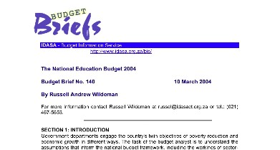

**Figure 6 - Sample IDASA Budget Brief**

**III What assessment can be made of the project?**

**a) What is the project’s impact?**

The available publications on the IDASA – EGP website are full of very useful data and clear policy recommendations that can aid in promoting public awareness of government spending, thus hopefully leading to demands for stronger government accountability and better public service provision. One analyst has noted that the quality of work coming out of IDASA, and specifically their work on budgets, has allowed them to conduct “quiet diplomacy” in a political context where opposition to the government is often not allowed. “[Their] approach, combined with its independent character, has ensured that even in government BIS (the old name for the EGP) work is highly valued” (Hofbauer 2008, 102).

**b) What is the cost of the project? Is it sustainable? Is it involved in partnerships with other organizations?**

The cost of the EGP appears unclear, but IDASA itself receives funding from a large group of external sources and its high status in South Africa seems to assure the sustainability of the initiative. Many of the subunits have engaged in partnerships with other organizations in their respective fields.

**c) What are the constraints, uncertainties, trade-offs and unintended consequences?**

One clear constraint comes in the EGP method for dissemination. Limited access to the Internet may lead to the exclusion of some of South Africa’s population from the findings of the EGP. Further, the EGP subunit’s publications, while providing detailed data and clear policy advice, nevertheless present this information in very technical terms that may not be comprehendible to all of South Africa’s population. Obviously as well, all of these publications rely on a literate public while this may not always be the case. This may therefore significantly hamper their information dissemination efforts. Lastly, it has been noted by other analysts that the dividing of the EGP into strong and autonomous subunits has lead to increased specialization at the expense of a clear EGP agenda. While this decentralization may prove beneficial in some respects, it may nonetheless have other inefficient and detrimental effects for the organization (Hofbauer 2008, 105).

***For more information on this initiative, you can visit: http://www.idasa.org.za/***

1. **CONCLUSION**

These initiatives constitute innovative ways of increasing accountability between citizens and rulers. As most of the initiatives are quite recent it is difficult to establish an accurate assessment of their impact. However, among the ones that have been running for several years such as the Directorio Legislativo (Argentina), we see evidence of very concrete results. The initiatives presented above are diverse and therefore raise very different issues and conclusions. We have chosen some key issues that caught our attention. Finding adequate solutions to some of these dilemmas might improve the projects’ impact and provide a better framework for their scaling up. Among these issues we have developed the right of access to information, the media, partnerships with MPs, funding and project independence, qualitative, versus quantitative data value and accuracy of data, the importance of networks and the involvement of citizens, scaling up, and finally, incentives, impact and evaluation.

**Right of access to information**

Right of access to information enforced by law is a basic prerequisite for rating systems. For example, for the Textbook count project (Philippines), monitors depended on the information concerning the procurement process provided by the government department. Similarly, The Directorio Legislativo initiative depended on the right of access to information in order to demand that MPS comply with their requests for information. In the case of Tanzania, there were some constraints due to the fact that local governments did not necessarily provide their expenditure evidence enough regardless of the central government’s order.

**Media** There is little evidence of the initiatives explored above engaging with media outlets in their respective countries. This may greatly hamper their dissemination efforts. Out of the projects reviewed, the Ugandan *Parliamentary Scorecard* (see appendix 2) engaged most directly with media in their context, reaching Ugandan citizens through TV, radio, and newspaper. Coupled with a historically strong and independent media sector in Uganda, this engagement can be said to be quite beneficial for the initiatives dissemination efforts. The Congreso Visible initiative in Columbia (see appendix 1) also shows some signs of positive engagement with media outlets. But the predominant method for dissemination for CV remains the Internet, thus allow room for more positive engagement with alternative media outlets.

It would thus seem a sound recommendation that initiatives seek to engage with media outlets in their efforts at information dissemination. Such a route may allow for these initiatives to reach out more broadly, and possibly provide their findings in less technical and more comprehensible ways. It is important to note though, that the success of this engagement with popular media sources relies on certain preconditions—literacy rates, independence of media from government, availability of radio/TV, etc. While merely publishing findings on the Internet or in print publications may provide media sources with valuable information, if the goal of these sorts of initiatives remains broad public empowerment through this information, engagement with popular media sources may be a good route to explore.

**Partnerships with MPs**

The Directorio Legislativo initiative puts the emphasis on the importance of good collaboration with MPs and legislatives structures. This aspect adds a political education component to the main objective of enhancing accountability. Both projects have reported important progress in the willingness of MPs to share their personal information. This aspect and the fact that it encourages the building of partnerships might be considered as an interesting positive externality. In the case of the Uganda Parliamentary Scorecard (see appendix 2), MPs’ suspicions and reluctance towards the project has constrained data collection and hindered potential project impact. Also, relying on MPs for information raises the risk of inaccurate information provided to suit the MP’s interests.

**Funding and project’s independence**

One of the crucial factors influencing the success of these initiatives is their ability to access reliable and steady funding. Especially since the product of these initiatives should be accessed by citizens for free, it cannot be considered as a source of revenue. The funding issue raises the problem of independence. In order for these rating systems to be of any value they need to maintain the objectivity of the information disseminated. Governments or private sources both generally come with strings attached. In some cases, raising funds from sources outside the country might also decrease the reports’ legitimacy. We can mention the example of the Textbook count project (Philippines) which does not rely on funds from government or public agencies in order to avoid risks that conflicting interests among stakeholders would undermine neutral evaluations. Maintaining independence might reduce potential source of fund. In this sense, there is a trade-off. The institutionalization of these initiatives by national laws might be a possible solution to guarantee permanent and non-conditional state funding.

**Qualitative versus quantitative, value and accuracy of data**

Mutual complementarity between qualitative and quantitative evaluation should be considered. For example, while Kokkai Giin Hakusyo project (Japan) provides ratings based on quantitative data which can be measured easily, it also needs qualitative information for sophisticated rating that can measure the MPs’ actual contributions to the parliaments. However, it is often difficult to reach a consensus in evaluating qualitative information, in particular in the case of debatable proposals. Therefore, a guideline which articulates the way of evaluating such qualitative information and thorough discussions for making it would be essential.

Most of the initiatives rating MPs cover very limited and mainly quantitative data such as average attendance or different criteria for measuring the participation of MPs in Parliament. The information provided hardly helps citizens to be informed about the actual legislative performance. The risk of biased information also exists. For example, under Japanese parliament system, ruling parties tend neither to use memorandum on questions nor to make private member’s bill, so these criteria cannot serve as a good indicator for evaluating their performance. Also FAFEN initiative may produce biased information about comparing performance of each party, because different parties hold different number of seats in the Pakistan parliament. These restrictive quantitative data also carry the risk of triggering indicator driven behavior of the rated MPs.

**Networks and Involvement of citizens**

Cooperation with civil organizations is essential for the projects implementation particularly in the case of participatory processes. The relationships between an organization leading a project and supporting groups will be a determinant of the success of the project. The leading organization should involve supporting groups and encourage them to implement activities in their community.

As mentioned in the first part of this paper, the main difference between systems rating service delivery and other rating systems, is that in most cases the latter are not carried out directly by citizens but by organizations who in the worst cases, spoon-feed them with their findings. In light of these observations, it seems important to raise the question whether citizen should or should not be involved directly in rating Parliaments and budgets. It is particularly crucial to address this issue in the case of pro-poor governance and pro-poor policies. When it comes to budget and policies, the whole literature on good governance and pro-poor governance insists on the importance of citizen’s participation. On the other hand it is quite obvious that budget allocation and policy design are complex and highly technical processes that require a certain expertise. Thus one of the questions raised by this overview of initiatives is how to reconcile these two truths.

**Scaling up, Impact and Evaluation**

Although, most of the initiatives are recent, we have nonetheless noticed a lack of systematic evaluation procedures. Measuring the impact of the initiatives is essential to modify the process and improve the outcomes. Congreso Visible (see Appendix 1) is one of the only initiatives that established a system to measure their impact based on several indicators. It is also difficult to evaluate the possibilities of scaling up. One of the exceptions is the Textbook count project which provides a good example of scaling up, as the model of this program was applied in other public services such as medicines distribution and school construction.

**Implications for Future Rating Systems**

Overall we can see that most of these initiatives have had mixed successes in providing citizens with sound information, which would theoretically allow them to make informed decisions about their rulers. Many initiatives have provided evidences that their work has reinforced the right to information and produces changes in the political culture. However there is little proof, especially in the case of MPs rating that citizens’ or MPs’ behavior has changed as a consequence of the new information available. In the case of budget monitoring, where the scrutiny is made by an organization with the necessary expertise, the results seem to be more tangible in terms of policy changes. These mitigated results raise the issue of enforceability mentioned in the literature review. Indeed, if the mechanisms to sanction rulers are not available or well functioning then the relevant information provided by the rating systems cannot be translated into incentives. The information provided by rating systems constitute potential incentives for behavior change, however the balance of incentives might not be in the citizens’ favor as many other elements such as clientelist traditions, kinship or other social and political realities often have more weight. Without taking all these elements in consideration it is very difficult to make an assessment of the impact of a rating system. This problem suggests that rating systems should be integrated in a larger set of initiatives aiming at improving all aspects of the accountability chain such as free and fair elections, strong political parties, competition in service delivery etc. Behavior change can be hard to achieve, especially on a short term basis and therefore the types of tangible impacts mentioned above—such as reinforcement of the right to information and changes in the political culture—might be at the current stage more realistic measures of success for rating systems than the actual creation of incentives that would motivate rulers to align their actions and decision-making with citizen’s preferences.

**Bibliography**

Africa Leadership Institute. 2007. *Parliamentary Scorecard 2006-2007: Assessing the Performance of Uganda’s Legislators*. Kampala: Africa Leadership Institute.

Ashoka, Innovators for the Public. 2007. *Changemaker | Government Watch.* <http://www.changemakers.net/en-us/node/737>. (accessed March 31, 2009).

Baron, M and N.A. Murray. 2008. *Directorio Legislativo*. Congreso de la Nation Argentina.

Brautigam, D. 2004. “The people’s budget: politics, Power, Popular participation and Pro-poor economic policy.” *Citizen participation and Pro-poor budgeting*. New York: United Nations Department of Economic and Social Affairs.

Cobbina, P. A. Macro-policy Formulation Process: Challenges for the Legislature for Enhancing Pro- poor Policy Making and Implementation**.** Regional Roundtable for SADC Parliamentarians, “Parliament's role in Poverty Reduction: Enhancing macro-economic policy approaches,” held 24 November 2006.

Congreso Visible. <http://cvisible.uniandes.edu.co/share/user/index.php>. (accessed March 29, 2009).

de Renzio, P. 2005a. Aid, Budgets and Accountability: CAPE Workshop Summary Paper. London: ODI.

de Renzio, P. 2005b. CSOs and Budgets: Linking Evidence and Pro-Poor Policies—Paper for the Civil Society Partnership Programme. London: ODI.

de Renzio, P. and Z. Curran. What do we mean by ‘pro-poor policies’ and ‘pro-poor  
 policy processes’?—Paper for the Civil Society Partnership Programme. London: ODI.

Departamento de Ciencia Política de la Universidad de los Andes. 2008. *Systematizacion, Programa Congreso visible.*

DFID Theoretical Issues’, Working Paper, York, University of York.

DFID. 2006. *White Paper, Eliminating World Poverty: Making Governance Work for the Poor*. London: DFID.

DFID. Effective States Team, Policy and Research Division**—**Governance and Transparency Fund (GTF). *Governance and transparency-some thoughts!* London: DFID.

Directorio Legislativo. <http://www.directoriolegislativo.org/>. (accessed March 25 2009).

Goetz, A. M and R. Jenkins. 2005. *Reinventing Accountability: Making Democracy Work for Human Development*. International Political Economy Series. Basingstoke: Palgrave Macmillan.

Goetz, A. M. and R. Jenkins. 2001. Hybrid Forms of Accountability: Citizen Engagement in Institutions of Public-Sector Oversight. *Public Management* *Review* 3 (3): 363-84.

Government Watch. 2007. Project Completion Report on the Civil Society Participation in Textbook Count 4. Makati City: Government Watch.

Hakizai Catalyst. 2004. Participatory Monitoring of PRS and Pro-Poor Expenditure in Selected Districts and Areas of Arusha Region, Tanzania. Arusha: Hakizai Catalyst

Hofbauer, H. 2008. Sustained Work and Dedicated Capacity-Building: IDASA’s Experience in Applied Budget Work in South Africa. In *Budgeting for the Poor*, ed. M. Robinson, 96-121. Hampshire: Palgrave Macmillan.

IDASA. Economic Governance Programme. <http://www.idasa.org.za/index.asp> (accessed March 29, 2009).

International Budget Project. 2006. Open Budget Initiative. *More Public Information Needed to Hold Governments to Account*. Washington D.C.: Center on Budget and Policy Priorities.

Japan Internet News Co., Ltd. 2008*. Kokkai Giin Hakusyo (Whitepaper of MPs).* <http://www.senkyo.janjan.jp/diet/dietinfo/> (accessed 31 March, 2009).

Keefer, P. and S. Khemani. 2003. Democracy, Public Expenditures, and the Poor: Policy Research Working Paper. Washington, D.C.: World Bank.

Khan, A. 2004. “Engaged governance” and Citizen Participation in Pro-Poor budgeting. *Citizen participation and Pro-poor budgeting*. New York: United Nations Department of Economic and Social Affairs.

Leftwich, A. 2006. ‘Drivers of Change: Refining the Analytical Framework. Part 1: Conceptual and Theoretical Issues’, Report for DFID by University of York.

Ministry of Internal Affairs and Communications (MIAC), Japan. 2008. 2007 White Paper: Information and Communications in Japan. Tokyo: Ministry of Internal Affairs and Communications, Japan.

O’Neill, T., M. Foresti, and A. Hudson. 2007. Evaluation of Citizens’ Voice and Accountability: Review of the Literature and Donor Approaches. London: DFID.

OECD GOVNET. 2009. Aid and Domestic Accountability: Background Paper. Prepared by Alan Hudson, ODI.

Ramkumar, V. 2008. Our money, Our responsibility, Washington D.C.: The International Budget Project.

Rocha Menocal, A. and B. Sharma. 2008. Joint Evaluation of Citizens’ Voice and Accountability: Synthesis Report. London: DFID.

Society for Participatory Research in Asia (PRIA), Social Accountability School. 2008. “Understanding Citizen monitoring.”

Weisband, E. and A. Ebrahim. 2007. Introduction: Forging Global Accountabilities. *Global Accountabilities: Participation, Pluralism and Public Ethics*. Cambridge: Cambridge University Press.

World Bank Institute and Canadian Parliamentary Centre. *Parliaments that work: A conceptual framework for measuring parliament performance.*

World Bank. 2004a. The World Bank Operations Evaluation Department. An Assessment of the Impact of Bangalore Citizen Report Cards on the Performance of Public Agencies, Working Paper Series No. 12. Washington, D.C.: World Bank.

World Bank. 2004b. *World Development Report 2004: Making Services Work for Poor People*. Washington, D.C.: World Bank.

World Bank. The Public Sector Governance Unit. *Accountability in Governance*. Washington D.C.: World Bank.

**APPENDIX**

**Appendix 1**

**Congreso visible (COLOMBIA)**

I **What is the project’s background?**

Congreso Visible (CV) was founded in 1997, shortly after the country had fallen into one of its biggest political and electoral crises in recent history. These events concerned a group of scholars at the University of Los Andes, who questioned the ethical and political suitability of the people that were being elected to the legislative branch and the absence of mechanisms to hold elected officials accountable for their actions. They concluded that part of this problem was due to the lack of information available to Colombians on congressional candidates and incumbents. They came to believe that by strengthening the ties between citizens and their political leaders and increasing their knowledge of each other, it would become possible for all sectors of Colombian society to rebuild confidence in their institutions. CV is home to the largest and most complete database on Congressional activity and candidates in the country. Unlike other information sources, CV offers this information free of charge to all members of Colombian society (Congreso Visible website).

II **What are the objectives of this project? Who and what does it rate? Who are the recipients of the information collected?**

CV is an organization dedicated to collecting, processing and disseminating information on candidates to Congress, as well as following up on the elected officials' performance while they are holding office. Congreso Visible has been supervising the Colombian Congress and promoting accountability among both legislators and citizens for seven years. Congreso Visible hosts the most comprehensive electronic database in Colombia on the work of the Congress. The Congreso Visible interactive website provides users access to information on participating congressional representatives, including their personal history, legislative activity and political platform. The website includes a discussion forum where citizens may exchange opinions, questions and recommendations on legislation being debated in congress and request information on legislative matters to be researched by staff. The questions and answers are saved on the website to allow the general public to learn more about the activities of the legislative branch. Thanks to the alliance made with major media and news agencies, Congreso Visible is able to disseminate reports, articles, analysis and expert opinions on legislative activity (Departamento de Ciencia Política de la Universidad de los Andes 2008)

CV provides this information so that citizens can make better judgments about who goes into congress; to make accurate, complete and impartial information available to journalists; and to give legislators the possibility of an alternative information source about themselves and their colleagues. CV produces two qualitative reports analyzing the accomplishments, trends and legislative agenda of the Congress. One report is published at the end of each of Colombia’s two congressional sessions. These reports examine the most important legislation and internal debates from each one of the two periods. The two reports are posted on the Congreso Visible website, distributed to the press and circulated on electronic bulletins in order to ensure the greatest visibility.

**III What assessment can be made of the project?**

**a) What is the project’s impact?**

CV has managed to provide the public with timely, clear and truthful information about the Congress and the administration of the parliament.

CV's Web page has become the most important source of information about the Colombian Congress. After almost seven years, almost 70 percent of the members of the Colombian Congress periodically and voluntarily provide Congreso Visible with information about their legislative activities. This means that a nonpartisan project has enabled members of Congress to understand the importance of citizens knowing what elected officials do and are able to evaluate them.

CV has established a system to measure their impact based on the following indicators:   
- Number of visitors to the portal   
- Number of inquiries and people involved in the online forum   
- Information entered into the new system

**b) What is the cost of the project? Is it sustainable? Is it involved in partnerships with other organizations?**

Financial resources come from international cooperation and small contributions from private entities that are the results of specific partnerships. Resources are managed by people who are part of the financial, administrative and legal team working at the Universidad de los Andes. CV has established partnerships with various organizations with specific expertise for the monitoring, analysis and evaluation of certain type of legislations.

**c) What are the constraints, uncertainties, trade-offs and unintended consequences?**

Perhaps the most important challenge for CV is to maintain its independence from both political parties and the government, as well as from particular economic interests. Additionally, it is important that more citizens have access to the information. These two elements are fundamental for creating, maintaining and increasing the credibility of a project like CV, both within legislatures and among citizens. Since many citizens still do not have access to the Internet, it is necessary to design alternative instruments and media to disseminate the information, such as public forums, newspapers, and the mass media in general (Departamento de Ciencia Política de la Universidad de los Andes 2008).

***For more information on this initiative, you can visit: http://cvisible.uniandes.edu.co/var/rw/CMS/temasDeActualidad/***

**Appendix 2**

**Parliamentary Scorecard 2006-2007: Assessing the Performance of Uganda’s Legislators (UGANDA)**

I **What is the project’s background?**

The *Parliamentary Scorecard 2006-2007* begins with the premise that, despite the Uganda Information Act of 2006, “most Ugandans still find it difficult to follow the activities of their government and cannot meaningfully assess the performance of their elected representatives” (Africa Leadership Institute 2007, 2). This has lead to a generally weak amount of participation by Ugandan citizens, and a subsequent lack of transparency and accountability between citizens and national government.

II **What are the objectives of this project? Who and what does it rate? Who are the recipients of the information collected?**

The *Parliamentary Scorecard 2006-2007* is a publication of the Africa Leadership Institute that seeks to present the Ugandan public “with accurate, objective, and comprehensive information about their elected leaders on an annual basis” (Africa Leadership Institute 2007, vi). The initiative rates Members of Parliaments (MPs) according to the clearly defined indicators of attendance, participation, and influence in both plenary and committee settings. By providing the average attendance and participation of all other MPs and the specific percentiles an MP falls into, the Parliamentary Scorecard makes it easy to draw comparisons between MPs. The main recipient of the collected information is the general public. The Africa Leadership Institute has begun dissemination campaigns, which entail visits to randomly chosen constituencies to hold “civic education workshops,” as well as dissemination efforts through TV, radio, and newspapers (Africa Leadership Institute 2007, 36).

**III What assessment can be made of the project?**

**a) What is the project’s impact?**

The content of the *Parliamentary Scorecard 2006-2007* allows for one to gain a very quick idea of the performance of a particular MP, both because the data is very clearly presented and because of the two grades (on an A – F scale) given for plenary and committee performance. As long as the publication itself and its findings are adequately disseminated, it can be expected that this initiative will broaden citizen knowledge of Ugandan MPs’ performances. Yet the success of this initiative relies heavily on enforceability accompanying this change in citizen awareness. Only with adequate enforceability will the end result be increased transparency and a better accountability relationship between Ugandan citizens and their MPs where these MPs reorient to their constituents’ needs and policy wishes.

**b) What is the cost of the project? Is it sustainable? Is it involved in partnerships with other organizations?**

The Royal Netherlands Embassy is a partner in the project and co-funded the *Parliamentary Scorecard 2006-2007* with the United States Department of State’s Human Rights and Democracy Fund. While funding appears to remain a challenge, the project has had success so far in attracting funds, and thus appears sustainable, as future funding relationships have already been established with other organizations.

**c) What are the constraints, uncertainties, trade-offs and unintended consequences?**

The success of this initiative appears to hinge on the success of the dissemination campaign. The *Parliamentary Scorecard 2006-2007* faces challenges in ensuring that their publication is read, that their civic education workshops engage an adequately large amount of citizens, and that their TV, radio, and newspaper campaigns reach a large amount of citizens. Along with funding issues, this initiative faces a very important challenge that was revealed after personal communication with the initiative: maintaining a good relationship with the Ugandan Parliament, which has at times been suspicious of the initiative.



Figure 5 - Uganda Parliamentary Scorecard 2006-2007

*For more information on this initiative, you can visit: http://www.aflia.org/work/story.php?id=15*

1. The terminology  “good governance” as used in this report refers to any institutional framework fostering development and characterized by accountability mechanisms, transparency and efficiency. It does not refer to a particular set of institutions defined as universally valid, as it often appears in the literature.